PO Box 1569
New Farm Q 4005
notar.com.au
0407644744

APPRAISAL OF RENTAL VALUE

Hyde Apartments
Beeston St

Teneriffe Q

Thank you for the opportunity to appraise these properties for their rental value.

A current rental analysis is below, providing you with the range in rental value that should be achieved at Hyde Apartments. I trust that the information will be of assistance for you.

When assessing the rental value of a property, we take into account factors ranging from similar properties in the area, age of similar properties, location, current vacancies and understanding all aspects of renting a brand new complex and ensuring all owners have quality tenants in the shortest possible time frame.

The range of rental value represents at one end, the minimum rent that should be achieved at the very beginning of letting Hyde Apartments, and at the higher end, what we would see as quite achievable once the complex is completely full and operational for 12 months.

Unit 13 - 2 Bedroom $580pw to $610pw

Yours faithfully
Notar Residential Building Management
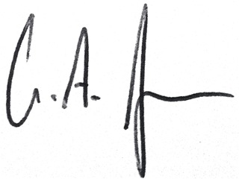

Glenn Swan
Principal
LREA - 3040614

